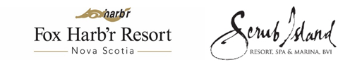
NEWS RELEASE

JOINT PARTNERSHIP BENEFITS RESIDENTS OF FOX HARB’R RESORT AND
SCRUB ISLAND RESORT, SPA & MARINA, BVI

Award-Winning British Virgin Islands Resort Complements Nova Scotia’s Charm

WALLACE, NS, May 24, 2016 - Fox Harb’r, Nova Scotia’s world class recreational and lifestyle destination, has entered into a unique partnership with Scrub Island Resort, Spa & Marina in the British Virgin Islands, one of the world’s most honoured private Caribbean resorts. During their first three years of ownership, Fox Harb’r residents will be entitled to a complimentary one-week stay in a one bedroom ocean view suite at Scrub Island Resort. In a reciprocal agreement, Scrub Island residents will be entitled to a complimentary one-week stay in a Harb'r Stone Village Town Home at Fox Harb’r Resort. Accommodations at both resorts feature space for entertaining and dining, gourmet kitchens with upgraded appliances, and master suites with luxurious ensuite bathrooms.

“We’re extremely pleased to partner with such an outstanding world class resort,” said Kevin Toth, Fox Harb’r President. “We believe our residents will feel very much at home at Scrub Island, as both properties feature the same level of unparalleled luxury, service and recreational options.”

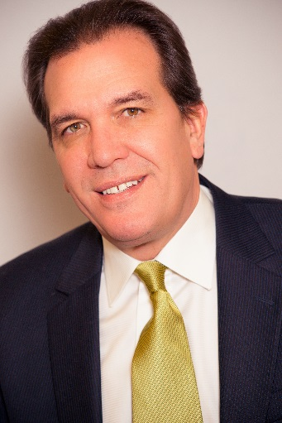
Kevin Toth
President
Fox Harb'r Resort
Wallace, Nova Scotia

Developed and owned by Mainsail Lodging and Development, Scrub Island is a 230-acre private island resort opened in 2010, located just 1.5 kilometres off the coast of Tortola. The resort has been honoured with numerous awards in recent years, including 500 World’s Best Hotels for 2015 by Travel + Leisure, World’s Dreamiest Private Island Resorts by both Huffington Post and Condé Nast Traveler, Best Romantic Getaways in the Caribbean by USA Today and was inducted into the 2015 Hall of Fame for Excellence by Trip Advisor.

“Our two resorts offer distinctive experiences, but share an unmistakable standard of luxury our guests will immediately recognize and appreciate,” says Joe Collier, President of Mansail Lodging and Development. “By matching a private Caribbean island resort with a singular destination in Nova Scotia, we’ve created a truly unique offering for residents.”

Fox Harb’r is set on 1,000 acres on Nova Scotia’s Northumberland shore, eight kilometers from Fox Harb’r Provincial Park. The Fox Harb’r resort offers world class golf and accommodations and private residences, along with fine dining, spa facilities, sports shooting and a full range of recreational activities. The resort is accessed by car, private jet or deep water marina.

-30-

ABOUT FOX HARB’R RESORT

Since owner Ron Joyce opened Fox Harb’r in 2000, the resort has offered Award-winning dining in the Cape Cliff Dining Room, the Willard for casual dining, the Dol-άs Spa, an 18-hole championship golf course, par 3 golf course, the Golf Academy at Fox Harb'r, Sport Shooting facility, private Jetport, deep sea marina and luxurious private single family homes and town homes which have made the Resort one of North America's most celebrated seaside retreats, located in Wallace, Nova Scotia, Canada. http://www.foxharbr.com/

CONTACT:
David Eisenstadt / Carol King / Nadia Ali
tcgpr
416 -696-9900 x 36 x 25 x 24
deisenstadt@tcgpr.com cking@tcgpr.com nali@tcgpr.com

About Scrub Island Resort, Spa & Marina, BVI

Opened in July 2010, Scrub Island Resort, Spa & Marina is named after its location, a serene 230-acre private-island haven situated at the east end of Tortola in the British Virgin Islands. The first luxury resort development in the destination in more than 15 years and first member of Marriott’s Autograph Collection in the Caribbean, the resort is tucked into a rugged cliff overlooking the Atlantic Ocean, Caribbean Sea and neighboring uninhabited islands. It features 52 guest accommodations as well as a collection of two-, three- and four-bedroom villas, the intimate Ixora Spa, world-class restaurants including the popular Caravela, three private beaches and a 55-slip marina. For more information, call toll free U.S. 877-890-7444 or visit scrubisland.com.

CONTACT:
Sarah Weaver Norwood Smith, VP, Sales & Marketing
Hayworth Public Relations Mainsail Lodging & Development
386-256-2583 / 404-220-9539 813-243-2634
sarah@hayworthpr.com nsmith@mainsailhotels.com

