**News Release**

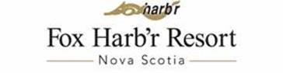

FOX HARB’R FLIES IN WITH MARITIME AIR AND ANNOUNCES TWO NEW GROUP PACKAGES

**WALLACE, NOVA SCOTIA, July 15, 2016** - Fox Harb’r ([www.foxharbr.com](http://www.foxharbr.com)) has announced a partnership with Maritime Air Charter Limited in Goffs, NS and two new getaway packages to the Nova Scotian resort.

Groups can choose between the Fly, Stay and Play or the Touch Down to Take Off Same Day Golf Experiences. Both packages are available to a minimum of eight guests and include chartered flights from Halifax International (Stanfield) Airport direct to Fox Harb’r Resort.

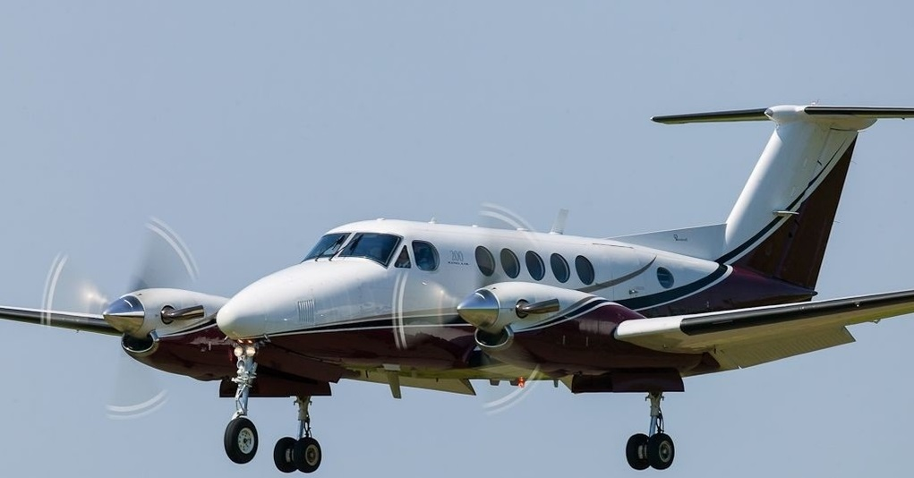

BE-20 Beech King Air 200

“For both packages, groups will get unlimited play on our Graham Cooke-designed Championship and Par 3 Seaside courses,” says Kevin Toth, Fox Harb’r President. “They’ll also have access to our practice facilities and everything that would be expected in a luxury day of golf: a cart, daily golf bag storage with club cleaning, lockers and shoe service.”

-2-

Maritime Air flights to and from Fox Harb’r are operated on a BE-20 Beech King Air 200 charter plane. Comfortably seating up to eight, the twin-engine turbo-prop aircraft features a roomy interior and leather seats for ultimate travel comfort.

“Guests will fly directly from the Halifax Stanfield Airport to Fox Harb’r’s private Jetport,” says Darryl Cross, Maritime Air’s Operations Manager. “The flight time is less than 20 minutes.”

Both packages include a Champagne Breakfast at Maritime Air Reception. The Touch Down to Take Off Same Day experience sees guests returned to Halifax International Airport that evening. “Fly, Stay & Play has the additional perk of one night accommodation at Fox Harb’r Resort in a Studio Suite,” added Toth.

-30-

ABOUT FOX HARB’R RESORT

Since opening in 2000, Fox Harb'r has offered Award-winning dining in the Cape Cliff Dining Room, the Willard for casual dining, the Dol-άs Spa, an 18-hole championship golf course, par 3 golf course, the Golf Academy at Fox Harb'r, Sport Shooting facility, private Jetport, deep sea marina and luxurious private single family homes and town homes which have made the Resort one of North America's most celebrated seaside retreats, located in Wallace, Nova Scotia, Canada.

ABOUT MARITIME AIR CHARTER LIMITED

Operating out of Goff, NS at the Halifax Stanfield International Airport, Maritime Air Charter Limited provides convenient and cost effective charter flights within Canada, the United States, Greenland and St. Pierre and Miquelon, France. Featuring two styles of aircrafts, the Beech King Air 200 and the Piper Navajo, Maritime Air Charter Limited understands your time is a valuable commodity.

CONTACT:

David Eisenstadt / Victoria Quiroz/ Carol King

tcgpr

416 -696-9900 x 36 x21 x25

[deisenstadt@tcgpr.com](mailto:deisenstadt@tcgpr.com) [vquiroz@tcgpr.com](mailto:vquiroz@tcgpr.com) [cking@tcgpr.com](mailto:cking@tcgpr.com)