**News Release**



FOX HARB’R TEAMS WITH PACIFIC LINKS INT’L

**WALLACE, NOVA SCOTIA, MARCH 17, 2016** - Fox Harb’r ([www.foxharbr.com](http://www.foxharbr.com)) and Pacific Links International ([www.pacificlinks.com](http://www.pacificlinks.com)) have partnered in an arrangement which links the Nova Scotian resort to a worldwide network of exceptional golf clubs.

“By joining with PLI, Fox Harb’r members will have access to golf courses around the world. Depending on the course chosen and its status as an Affiliate or Reciprocal Access Club, members and residents will enjoy discounted or waived green fees and guest access for members of the affiliate network,” said Fox Harb’r President Kevin Toth.

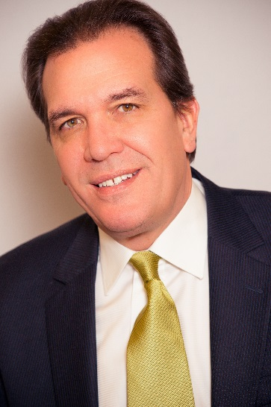

Kevin Toth

President

Fox Harb'r Resort

Wallace, Nova Scotia

Along with their own courses PLI’s network has two types of clubs, Affiliate and Reciprocal Access.

At Affiliate and PLI clubs, Fox Harb’r members and residents enjoy golf privileges that include waived green fees and guest access, subject to each club’s guest policies, with a guest fee.

-2-

At Reciprocal Access clubs Fox Harb’r members and residents will enjoy a discounted green fee. At all clubs, members will be granted, subject to availability, four rounds of golf per 30 day period per participating club.

“Fox Harb’r members and residents will be issued a Pacific Links International membership card,” added Toth.

PLI, Affiliate and Reciprocal Access members will enjoy similar benefits at the Fox Harb’r course. PLI and Affiliate members are granted access without payment of a guest or green fee, while Reciprocal Access members will have a 50 per cent discounted green fee. Fox Harb’r will offer four tee times per day to members to book up to two weeks in advance, provided tee times are available.

Said Toth, “With over 80 Affiliate, Reciprocal Access and Preferred Access clubs internationally, the partnership between Fox Harb’r and Pacific Links opens a whole world of golf to our members and residents. With Pacific Links planning expansions into the United Arab Emirates, Japan, South Korea, Portugal and Spain, that world is only going to get bigger.”

-30-

ABOUT FOX HARB’R RESORT

Since its opening in 2000, Fox Harb'r has offered Award-winning dining in the Cape Cliff Dining Room, the Willard for casual dining, the Dol-άs Spa, an 18-hole championship golf course, par 3 golf course, the Golf Academy at Fox Harb'r, Sport Shooting facility, private Jetport, deep sea marina and luxurious private single family homes and town homes which have made the Resort one of North America's most celebrated seaside retreats, located in Wallace, Nova Scotia, Canada.

CONTACT:

David Eisenstadt / Carol King /Victoria Quiroz

tcgpr

416 -696-9900 x 36  x25  X21

[deisenstadt@tcgpr.com](mailto:deisenstadt@tcgpr.com) [cking@tcgpr.com](mailto:cking@tcgpr.com) [vquiroz@tcgpr.com](mailto:vquiroz@tcgpr.com)