**NEWS RELEASE**



**NOVA SCOTIA’S FOX HARB’R RESORT RETAINS**

**tcgpr AND MCOUAT PARTNERSHIP**

**WALLACE, Nova Scotia, March 11, 2016** – FOX HARB’R RESORT ([www.foxharbr.com](http://www.foxharbr.com)) has retained tcgpr of Toronto as its public relations consultants of record and McOuat Partnership of Markham, ON as its marketing/advertising agency of record, effective immediately.

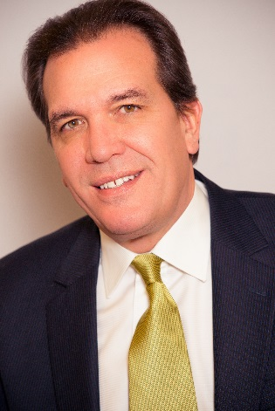

Kevin Toth

President

Fox Harb'r Resort

Wallace, Nova Scotia

Said Fox Harb’r President Kevin Toth, “both firms will work to promote the Resort’s superior amenity experiences and support Milborne Real Estate’s mandate to market our luxury real estate offerings of single family and town homes, throughout North America and the world.”

Milborne Real Estate is managing the sales of Fox Harb’r Residences, a luxury collection of 14 town homes, one custom single family home and 23 homes sites, where fractional ownership will also be a purchaser’s opportunity.

A  Five Star luxury destination resort on Nova Scotia’s Northumberland Coast, Fox Harb’r is a two-hour scenic drive from Halifax and Moncton.   With its own private Jetport 5000 foot airstrip, the Resort is about a two-hour flight from Toronto, Montréal, New York and Boston.

Said Fox Harb'r Resort owner Ron Joyce, who is the co-founder of Tim Horton's, “In 1987, when I first saw this marvelous property, I thought, this should be a national park. Five hours later I became the lucky owner of 1,100 acres of wilderness on the water, with six kilometres of ruggedly beautiful oceanfront shoreline.  I decided to build something outstanding, to give back to the community because Tatamagouche, just down the road, is my home town.”

Well-known for its Graham Cooke-designed 18-hole Championship golf course and Executive 9-hole par 3 golf course, its Dol-as Spa and deep sea marina, Fox Harb’r has two popular restaurants ...the Cape Cliff Dining Room and The Willard for casual dining.

Another amenity is the 25-acre Vineyard a Fox Harb'r. Home owners will also have a section of the vineyard where each will have a row mast head and be able to partake in the growing and harvesting of the grapes plus have an opportunity to have a specific estate bottling labelled for themselves,“ said Toth.

The Resort also sports world-class Resort Clay Shooting facilities.  “We’re known as the finest Clay Shooting Facility in Canada where we’ll host four world class events this year,” said Toth.

-30-

CONTACT:

David Eisenstadt / Carol King

tcgpr

416 -696-9900 x 36  x25

[deisenstadt@tcgpr.com](mailto:deisenstadt@tcgpr.com) [cking@tcgpr.com](mailto:cking@tcgpr.com)