NEWS RELEASE

FOX HARB’R RESORT TO HOST FOUR MAJOR
SPORT SHOOTING EVENTS IN 2016

REVISED
WALLACE, Nova Scotia, April 4, 2016 – Fox Harb’r Resort, Nova Scotia’s world-class luxury recreational, residential and lifestyle destination, will host four major Clay Shooting events during the 2016 season.

“We are delighted to be able to attract these major Clay Shooting events in 2016,” said Kevin Toth, President of Fox Harb’r Resorts. “We’ve said we’re the best kept secret in sport shooting, but that secret is now out. We believe this recognition of our facilities is testament of the unique world-class nature of Fox Harb’r as Atlantic Canada’s leading full-service recreational resort and residential development.”

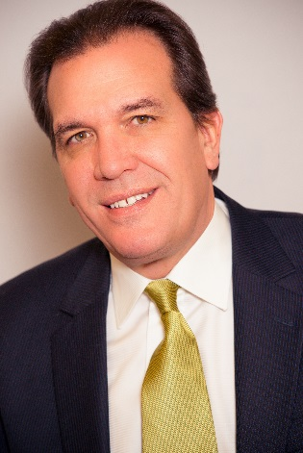
Kevin Toth
President
Fox Harb'r Resort
Wallace, Nova Scotia

Beginning in May over the Victoria Day Weekend and continuing through September, Fox Harb’r’s Clay Shooting facilities will host:

-2-
- Fox Harb’r Spring Classic - May 20, 21 & 22
Hosted and targets provided by 26-time World Clay Shooting Champion George Digweed.

- Fox Harb’r Cup - June 17
Course set by Don Currie, Chief Instructor of NCSA and Professional Coach. NSCA Registered 100 Clay Competition.

- Maritime Cup - July 29, 30 & 31
A registered shoot. Target set by well-known Canadian shooter and Coach Peter Cheifari. Make-a-Break and Super Sport through the event. Total prize purse valued at $5,000.

- Canada’s Atlantic Cup - September 9, 10 & 11

A NSCA registered shoot. Hosted and targets set by 26-time World Clay Shooting Champion George Digweed. Total prize purse valued at $5,000.

Said George Digweed, “I’m very pleased to be associated with this five star Resort and an organization that’s so passionate about perfection. As it stands, Fox Harb’r is a phenomenal site and I’m so looking forward to working with their Team as this season’s events unfold.”

Added Toth, “With our various other luxury amenities, Fox Harb’r Resort offers regular and Five stand Sport Shooting clays and Pheasant Wing shooting. The 15-acre sporting clay course has 24 Shooting Stations for our guests’ challenge and enjoyment. As Fox Harb’r is already a licensed shooting facility, individuals visiting do not require a permit to partake in the fun.”

-30 -
ABOUT FOX HARB’R RESORT

Since its opening in 2000, Fox Harb'r has offered Award-winning dining in the Cape Cliff Dining Room, the Willard for casual dining, the Dol-άs Spa, an 18-hole championship golf course, par 3 golf course, the Golf Academy at Fox Harb'r, Sport Shooting facility, private Jetport, deep sea marina and luxurious private single family homes and town homes which have made the Resort one of North America's most celebrated seaside retreats, located in Wallace, Nova Scotia, Canada.
-3-
CONTACT:
David Eisenstadt / Carol King /Victoria Quiroz
tcgpr
416 -696-9900 x 36 x25 X21
deisenstadt@tcgpr.com cking@tcgpr.com vquiroz@tcgpr.com

