**News Release**



FOX HARB’R INTRODUCES TRAIL RIDES WITH FOREVER MEMORIES EQUESTRIAN PARTNERSHIP

**WALLACE, NOVA SCOTIA, August 10, 2016** - Fox Harb’r ([www.foxharbr.com](http://www.foxharbr.com)) now offers horseback trail rides in a partnership with Forever Memories Equestrian.

Trail rides operate at Beginner to Advanced levels, ensuring riders can enjoy the variety of Fox Harb’r Resort vistas. The horses are gentle and professionally-trained. Expert trainers and guides promise guests and residents a memorable riding experience, as they ride through the Resort’s scenic pastures, explore forested areas and experience the stunning views of the Oceanside and beach.

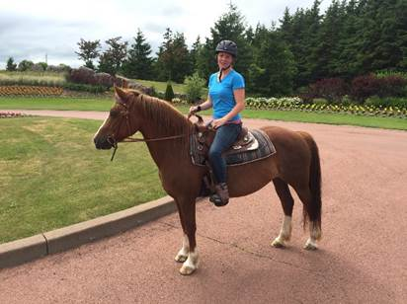

A Fox Harb’r rider on Forever Memories’ Jill

“Six horses are on-site at Fox Harb’r,” said Shelbi Gatti, Forever Memories’ owner. “We have two trail guides that are employees of Forever Memories that lead the rides.  The trails are available to riders of all skill levels. Experienced riders can have their trail rides at faster, more challenging paces,” Gatti added.  Horses are stabled on-site at Fox Harb’r and can be booked through Guest Services.

“While we want our guests and residents to experience horseback riding the way it was meant to be, in a gorgeous natural setting, everyone’s safety is of the utmost importance,” said Fox Harb’r President Kevin Toth.

-        30   -

ABOUT FOX HARB’R RESORT

Since its opening in 2000, Fox Harb'r has offered Award-winning dining in the Cape Cliff Dining Room, the Willard for casual dining, the Dol-άs Spa, an 18-hole championship golf course, par 3 golf course, the Golf Academy at Fox Harb'r, Sport Shooting facility, private Jetport, horseback riding, deep sea marina and luxurious private single family homes and town homes which  make the Resort one of North America's most celebrated seaside retreats, located in Wallace, Nova Scotia, Canada.

ABOUT FOREVER MEMORIES EQUESTRIAN

Forever Memories Equestrian Centre is a western riding facility focused on providing an educational, fun and professional experience. The centre offers riding lessons, trail rides in beautiful Victoria Park, as well as birthday party, day camp and therapy services. Owner Shelby Gatti began teaching horse riding at the age of 14 and started Forever Memories with one horse and one saddle. Today 23 horses reside at the centre, along with goats, bunnies, a pig, donkey and llama.

CONTACT:

David Eisenstadt / Nadia Ali

tcgpr

416 -696-9900 x 36  x 24

[deisenstadt@tcgpr.com](mailto:deisenstadt@tcgpr.com) [nali@tcgpr.com](mailto:nali@tcgpr.com)