**News Release**



FOX HARB’R ANNOUNCES NEW REAL ESTATE OFFERINGS

**WALLACE, NOVA SCOTIA, July 27, 2016** - Fox Harb’r ([www.foxharbr.com](http://www.foxharbr.com)) has made new real estate offerings available to those looking to purchase.

The Nova Scotian resort is offering two years of free membership dues, membership with Pacific Links Golf Courses and one week at the Scrub Island resort to anyone who buys an Executive Townhouse before August 31.

Purchasers can choose between buying a ¼ share of the Executive Townhouse or whole ownership. The townhomes are move-in ready and fully furnished.

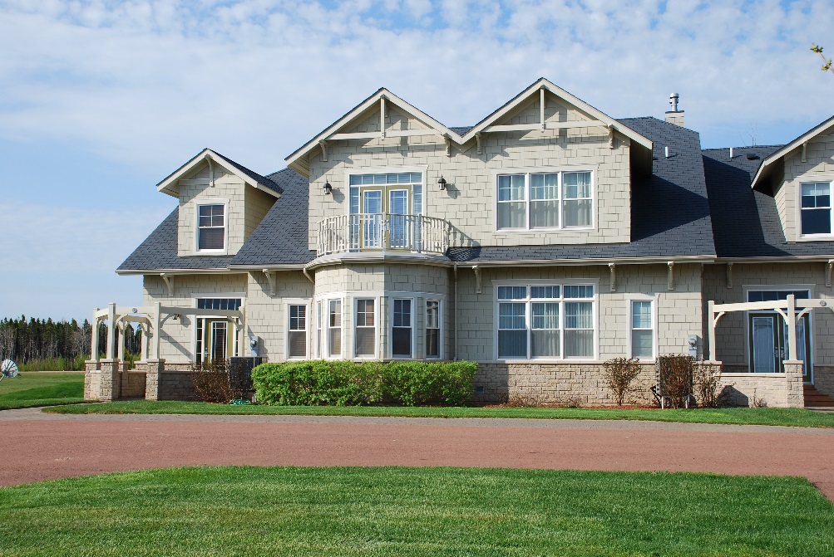

The Royal Cumberland, one of the resort’s Executive Townhomes

“All of our villas in the Fox Harb’r Stone Village are at the same level of luxury and comfort as the rest of the resort,” said Fox Harb’r President Kevin Toth. “The open-concept homes all have three bedrooms, three bathrooms, gas fireplaces and spectacular views of either our championship golf courses or the Atlantic Ocean.”

Membership with Pacific Links Golf Courses gives owners access to golf courses around the world. Depending on the course and its status as either an Affiliate or Reciprocal Access club, residents will enjoy discounted or waived green fees and guest access.

-2-

“For the first three years of ownership residents will be entitled to a one week stay Scrub Island Resort, Spa & Marina in the British Virgin Islands,” said Toth. “Scrub Island is world-class resort and we believe our residents will feel very much at home there.”

Pricing starts at $169,900 for a quarter share, and goes to $1 million.

-30-

ABOUT FOX HARB’R RESORT

Since opening in 2000, Fox Harb'r has offered Award-winning dining in the Cape Cliff Dining Room, the Willard for casual dining, the Dol-άs Spa, an 18-hole championship golf course, par 3 golf course, the Golf Academy at Fox Harb'r, Sport Shooting facility, private Jetport, deep sea marina and luxurious private single family homes and town homes which have made the Resort one of North America's most celebrated seaside retreats, located in Wallace, Nova Scotia, Canada.

About Scrub Island Resort, Spa & Marina, BVI

Opened in July 2010, Scrub Island Resort, Spa & Marina is named after its location, a serene 230-acre private-island haven situated at the east end of Tortola in the British Virgin Islands. The first luxury resort development in the destination in more than 15 years and first member of Marriott’s Autograph Collection in the Caribbean, the resort is tucked into a rugged cliff overlooking the Atlantic Ocean, Caribbean Sea and neighboring uninhabited islands. It features 52 guest accommodations as well as a collection of two-, three- and four-bedroom villas, the intimate Ixora Spa, world-class restaurants including the popular Caravela, three private beaches and a 55-slip marina.  For more information, call toll free U.S. 877-890-7444 or visit [scrubisland.com](http://www.scrubisland.com).

CONTACT:

David Eisenstadt / Victoria Quiroz/ Carol King

tcgpr

416 -696-9900 x 36 x21 x25

[deisenstadt@tcgpr.com](mailto:deisenstadt@tcgpr.com) [vquiroz@tcgpr.com](mailto:vquiroz@tcgpr.com) [cking@tcgpr.com](mailto:cking@tcgpr.com)